11 FEBRUARY 2022
INTERNATIONAL DAY OF WOMEN
AND GIRLS IN SCIENCE

Online roundtable

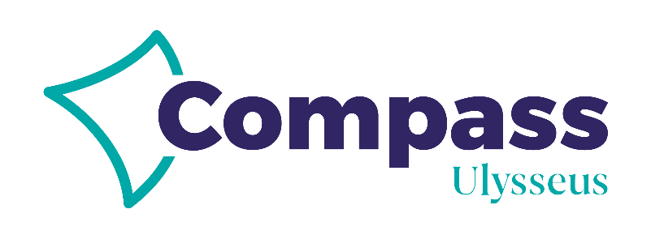

BACKGROUND INFORMATION:

The International Day of Women and Girls in Science is celebrated on the 11th of February and is implemented by UNESCO and UN Women, in collaboration with intergovernmental agencies and institutions, as well as civil society partners, that aim to promote women and girls in science. The day's purpose is to promote full and equal access to participation in science for women and girls and to recognize the critical role of women and girls in science, not only as beneficiaries, but also as agents of change.

Ulysseus European University is fully committed with the promotion of social cohesion and citizen engagement through different programs and activities. In fact, by 2030, Ulysseus will have contributed to a more inclusive and engaged society, promoting equality, social cohesion and active citizenship through a number of pilot phases including The Gender Equality Agenda which aims at addressing, among other threats, the under-representation of women is scientific and technical subjects (the so-called STEAM, adding ARTS), including the digital sector, and subsequently in related professions.

Additionally, Ulysseus continues its focus on gender equality in the field of research and innovation on its project COMPASS - Leading Ulysseus to become a European University excellence model through Research and Innovation. Under Work Package 5 “Responsible Research and Innovation”, led by Universita' di Genova, the alliance will share, spread, and train in Ulysseus best practices to involve citizens, civil society and public/cities authorities in the R&I activities, including a responsible perspective for gender issues, ethics, public engagement and science education in R&I. The activity proposed below is fully aligned with the latest.

ABOUT THIS ACTIVITY:

Type of activity: Online Roundtable

Length: 1.5 hours – 2 hours

Target audience: Young students

Participants:
6 young female researchers (Phd candidates) from partner universities
6 young students (16-18 year old) proposed by partner universities

Moderator: Prof Roberto Spotorno, DCCI

Format:
- Moderator introduces Ulysseus & Compass and explains the structure of the
roundtable (5 min)
- 6 young researchers introduce themselves (12 min approx., 2 min each)
- 6 young students introduce themselves (their names, the high school they come from and what area of science is of their interest, for example) (12 min., 2 minutes each)

THEME 1 – Developing a scientific career (30 min)
3 young students launch 1 question addressed to young researchers. Students should have camera on while asking the question and during the answer, then off to avoid having too many people on screen.

(Moderator may decide whether to ask the question to all or just to some of the researchers so that everyone can participate)

THEME 2 - Challenges faced towards gender/resistance (30 min)
3 young students launch 1 question addressed to young researchers. Students should have camera on while asking the question and during the answer, then off to avoid having too many people on screen.

(Moderator may decide whether to ask the question to all or just to some of the researchers so that everyone can participate)

WRAP UP - Moderator asks 6 young researchers to briefly give a tip to young girls who are interested in science to finish with a tip and a call to action.
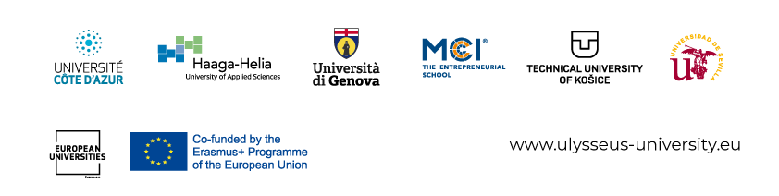

COMPASS has received funding from the European Union’s Horizon 2020 research and innovation programme under the grant agreement No 101035809. The views and opinions expressed in this communication are the sole responsibility of the authors and do not necessarily reflect the views of the European Commission.

